The Martian (Book by Andy Weir)

1) In at least 3 complete sentences, describe the Martian landscape.

2) The main character, Mark Watney, keeps track time using “sol”. What does “sol” refer to?

3) What 3 items does Mark need to survive and in what order?

1.

2.

3.

4) If he dies on the planet, why won’t his body decompose?

5) What is the chemical equation for making water from oxygen and hydrogen? (Hint: oxygen = O₂ and hydrogen = H₂).

6) What is the hydrogen and oxygen really used for?

7) What does “hab” refer to?

8) When Mark is in the rover, there is a group of display screens showing psi, ºC, %O and Sol. Sketch out the display below and include the values in each box.

9) Here are a few other strings of letters and numbers NASA sends to Watney in the books. Can you figure them out using the “Hex” and “Char” columns of the ASCII table?
1. 48 4F 57 41 4C 49 56 45

2. 43 52 4F 50 53 3F

3. 42 52 49 4E 47 53 4A 52 4E 52 4F 55 54

10) Write your own sentence out in hexadecimal below:

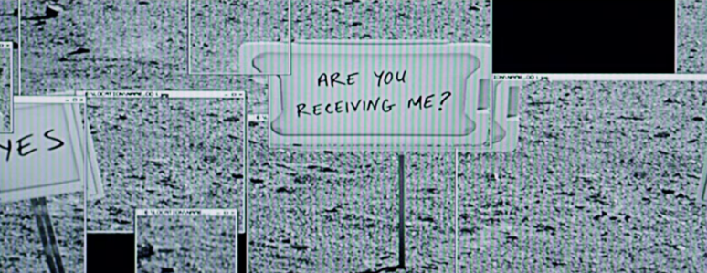
What you should know before seeing the movie The Martian

1. How to get to Mars

The first scene in "The Martian" takes place on Mars, but how would humans even get there? NASA estimates it would take about six to eight months with space travel technology we have now. In "The Martian," Watney and the rest of the crew use the fictional Hermes spacecraft to reach the red planet.
On a real trip to Mars, we'll have to worry about the astronauts losing muscle mass and bone density while spending so much time in a microgravity environment. Space is also filled with dangerous cosmic radiation that can rip through a human's very DNA.
The Hermes has artificial gravity and a radiation shield to make the journey more comfortable for the crew. NASA is working on developing both of those things, but it has along way to go.

2. What it's like on Mars

Here's what Mars is like, according to NASA:
- Mars has a reddish-orange glow during the day from all the dust.
- Sunrises and sunsets appear blue because Mars has almost no atmosphere.
- One day or "sol" on Mars is a few minutes longer than an Earth day.
- One Martian year is nearly two Earth years. That's because Mars orbits the Sun much farther away than Earth, so it takes a lot longer for the red planet to complete one lap.
- The average surface temperature on Mars is a chilly minus-80 degrees Fahrenheit. But temperatures can swing from a low of about minus-195 degrees Fahrenheit in winter, to a comfortable 68 degrees Fahrenheit during the summer.
- Gravity on Mars is only about 40% that of Earth's, so you'd be 60% lighter (but not moon-bouncing light).
- Mars has barely any atmosphere — about 1% of the density of the cozy atmospheric blanket around Earth. That's hardly enough to protect the surface from dangerous space radiation.
- Dust storms can envelope the planet for days at a time. It's a pretty inhospitable place. Good luck, Watney.

3. NASA's Plutonium batteries
Watney digs up a radioactive power source in "The Martian." It's called a radioisotope thermoelectric generator (RTG), and NASA relies on them for long-distance space missions.
RTGs are essentially batteries powered by radioactive plutonium-238. As the plutonium naturally decays, it generates heat, and the battery casing turns the escaping warmth into electricity.
Plutonium-238 is pretty much impossible to turn into a nuclear weapon, according to the Environmental Protection Agency. It's also not the kind of dangerous, skin-piercing radiation that humans have to worry about (unless it gets inside our lungs). Still, a nuclear battery is dangerous to have around because it's very hot.
4. Communicating with Mars from Earth
Mars is so distant that it takes 15 to 20 minutes for a message sent from Earth to make it to there.
That's because a communication signal like a radio wave travels at the speed of light, and nothing can travel faster: Mars is about 140 million miles away from Earth, and the speed of light is about 671 million mph.

5. So, what is the hexadecimal system you see on screen?
The hexadecimal system is comprised of 16 symbols: 0-9 and A-F. Typically it's used by programmers to condense and communicate large binary numbers easily.

It's also used to communicate data. After putting signs for the 16 digits and numbers in a circle around Pathfinder, Watney combines the hexadecimal system with an ASCII table in both the book and movie. ASCII is a code that represents characters as numbers and is used to help display text onto computers among other devices.

An ASCII table contains 255 characters where each is assigned a number ranging from 0 to 255.
An easier way to think of it is by considering all the options on a smartphone keyboard. Now, imagine you only had 255 of those characters to choose from and each of those was assigned a number from 0-255. That's your ASCII table. Essentially, the ASCII table can be used as a giant decoder.

Here's how it looks:
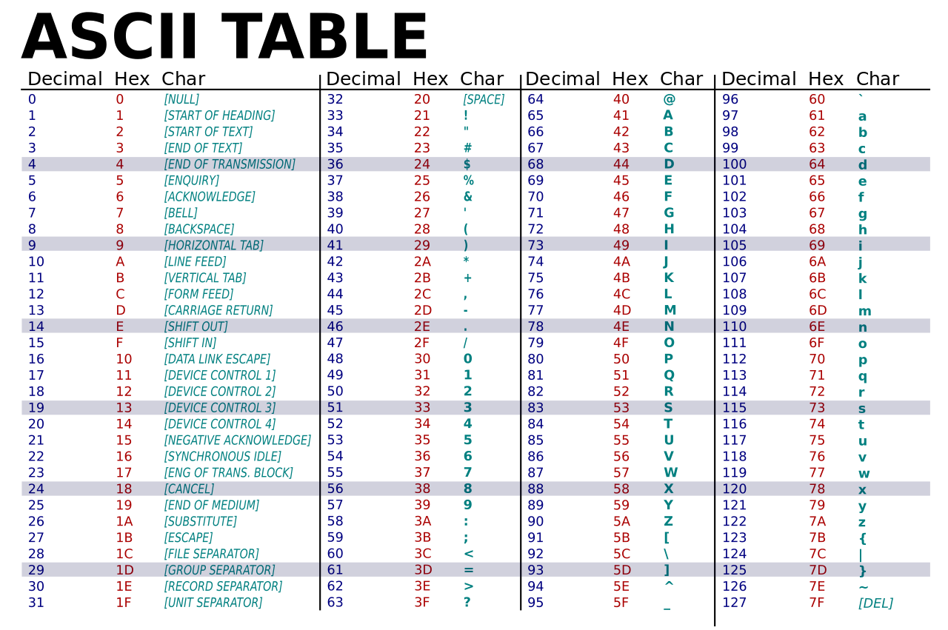

The important columns for "The Martian" are the ones labelled "Hex" and "Character."

When NASA points to a pair of hexadecimal digits, or hex digits, they can send any letter of the alphabet and character they want.

So if NASA wanted to say "STATUS" as they do in the book to Watney, they would point to the following pairs of letters and numbers: 53, 54, 41, 54, 55, 53.

