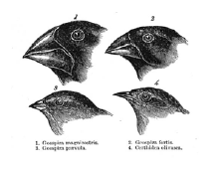

Battle of the Beak Lab Analysis

- What scientific phenomenon was this lab demonstrating?

- According to the averages, rate the utensils in order from most successful to least successful.

- Which phenotype (physical characteristic) do you think helped the most successful utensil to be so good at getting food?

- Advantageous characteristics, when nature selects for them, are called____________________.

- Which beak types will most likely go extinct and why?

- What if all the birds flew to an island where the only food source was macaroni…which birds would flourish and which would go extinct?

- Explain antibiotic resistance in your own words.

- How do the elements of natural selection result in differences in reproductive success? (inherited variation, potential of a population to produce more offspring than can survive, and a finite supply of environmental resources)

- What is “fitness?”

- What is “Genetic Variation?”

- Why is genetic variation necessary for natural selection to occur?

- Why does natural selection produce change in populations rather than individuals?

