Name: ______________________________ Date: _____________ Period: ______

Ecology Test Review

- Use the diagram to label and define each level of organization in ecology.
Example:
Biosphere-All the living spaces of the earth, areas of the earth that support life.

Biome is defined as a primary _____________, primary ____________, and
primary _____________________.
Some examples are …

A group of the same species/organism living and interacting in a given area is a_________________________ .
An example from our “Field Day” is a ______________________

All the same organisms/species living and interacting in a given area id called a ______________________

Organism

- Describe the climate (temperature and rainfall and resulting seasons) of the following biomes:

  - Tundra:
  - Tropical Rainforest:
  - Desert:
  - Temperate Grassland:

- What is ecology? ( -ology = study of) (-ecos = habitat or environment)

- What is an abiotic factor? Give 3 examples.

- What is a biotic factor? Give 3 examples.

- Define the following roles/niche in an ecosystem and give an example of each:

  - producer:
  - consumer:
  - decomposer:
  - scavenger:
  - herbivore:
  - carnivore:
  - omnivore:

- Define a limiting factor in ecology? Give an example from “Oh Deer!”.

- What is the biodiversity of an ecosystem?

- What is sustainability?

- How is biodiversity related to its sustainability?

- How do ecosystems maintain homeostasis (balance)? Use example from Oh Deer activity.

- What is the difference between a food chain and a food web?

- Using the food web below, explain what would happen if the deer population decreased significantly.

___________________________________
___________________________________
___________________________________
___________________________________
___________________________________
___________________________________
___________________________________
___________________________________
___________________________________
___________________________________
___________________________________

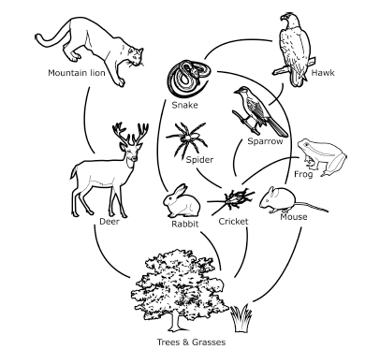

- What do the arrows represent in a food chain or food web?

- What happens to the amount of energy in food chain as you go up the energy pyramid?

- Describe the process of photosynthesis. Include the chemical equation. (Retro back in your journal for information on Photosynthesis. This information is important enough to test again.)

- Draw a picture and explain geotropism.

- Draw a picture and explain phototropism.

