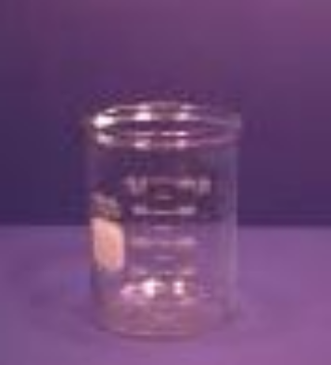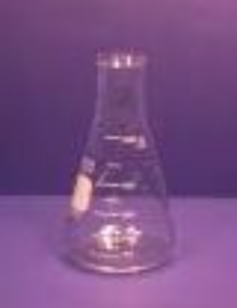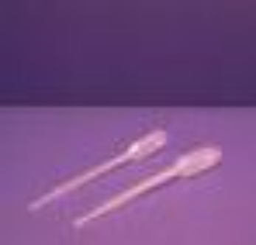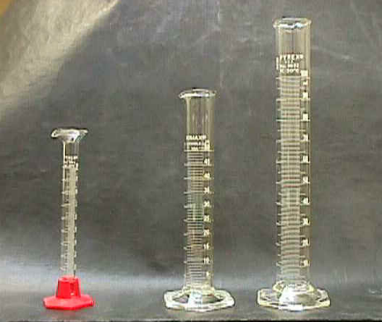
Beaker Erlenmeyer Flask Pipet Graduated Cylinder

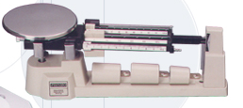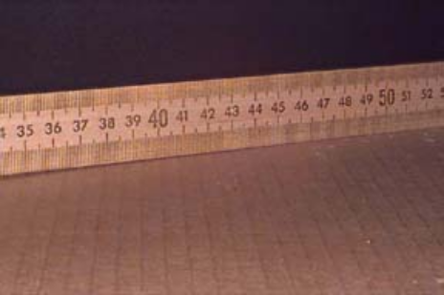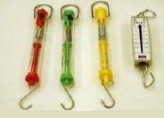
Triple Beam Balance Meter Stick Spring Scale
We do Not use inches in science. The System de International or SI system uses metrics in science so the whole world can communicate together.

Meter Stick – Use Metric Side 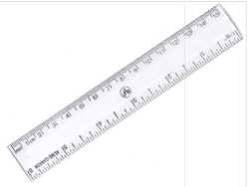

mm (milli-meter), cm (centimeter), m (meter), km (kilometer)

