Name ___________________________________pre-quiz Safety Quest August 20,’21
NOT 4 A GRADE JUST YET BUT U WILL SEE THIS AGAIN!
- When beginning a lab in science class you must always first __________ the entire lab and always _______________ _______________ if you do not understand any information before beginning.

- When working with chemicals or any preserved specimens that could splash you should always wear ___________________________________ .

- If a lab requires you to check an odor, describe how should you “smell” the item.

- What does P.P.E stand for? _____________________ ______________________ __________________

- Name five P.P.E. s
  - _____________________

  - _____________________

  - _____________________

  - _____________________

  - _____________________

- When using a graduated cylinder you always read the amount of liquid at the bottom of the line called the _______________________.

- There is never any horseplay of any kind allowed. Why?

- On the Meter stick below, label the longest measure and the shortest measure.

a._______________________ b. ________________________

9. What is (a.) the name of the instrument used in the picture below and
(b.) what is the value of the mass in the picture?
a. ______________________________________________________________
b._________________________ 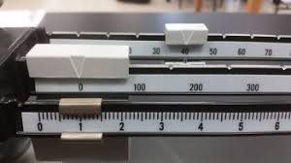
- Graduated cylinders measure volume in _________________________________.

Extra credit: If a starting value of 35 mL is in a graduated cylinder and you gently slide a rubber whale shark in to the cylinder and the value changes to 46 mL, what is the irregular shape volume of the whale shark? (Show your work below.)

Answer ____________________________.

