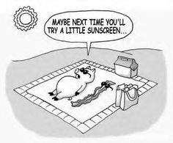 | Skin Deep
Our skin is the largest organ in our body. Skin can be thin like the eyelids, or it can be thick like the skin on the soles of our feet. Skin can be hairy like our heads, or smooth like our lips. No matter the differences in our skin, it protects us from things such as bacterial, harsh chemicals, and the sun’s ultraviolet rays, and it keeps us from drying out. The skin informs us about our world via sensory receptors that respond to things such as pain, pressure, touch, and temperature. Receptors (nerve endings) send impulses along the sensory nerves to the brain. Our skin also helps us with climate control. It contains sweat glands that release perspiration through our pores to help cool us when we’re hot. The skin contains blood vessels that also help us control our body temperatures. When we get too hot, the blood circulation is stepped up. Blood vessels near the surface dilate, carrying some of our internal heat to the surface where it is lost to the air. One of our skin’s responses to cold is goose bumps. Goose bumps are caused by the contraction of tiny muscles (erector pili) at the bottom of each hair. They cause our body hairs to fluff up, forming an insulating layer of air that helps keep us warm.
There are three major layers of skin.
  - The top layer is the epidermis. This is the layer you can see. The base of the epidermis is where new skin cell are made. The top of the epidermis contains dead skin cells that slough off. The epidermis also makes melanin. Melanin helps protect the body from the sun’s ultraviolet rays.
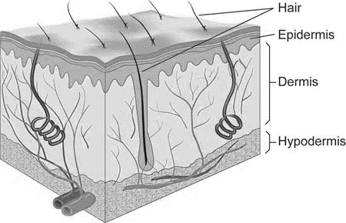
  - The middle layer is the dermis. It contains blood vessels, oil and sweat glands, nerve receptors, and hair follicles. Blood vessels deliver oxygen and nutrients to the cells. They also take away carbon dioxide and other wastes. Oil glands (sebaceous glands) lubricate our skin and help it to be waterproof. The oil (sebum) also coats our hair, making it shiny. Sweat glands aid our bodies in maintaining an adequate body temperature. (When sweat is evaporated, our bodies are cooled.)
  - The bottom layer of the skin is the hypodermis or subcutaneous layer. It is made up of mostly fat. The fat helps keep us warm. It also helps cushion bumps to our bodies. The hair follicles are rooted in the subcutaneous layer.

