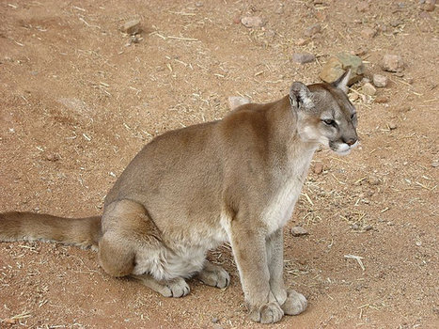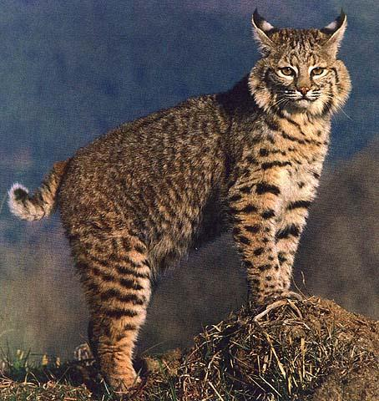
A B

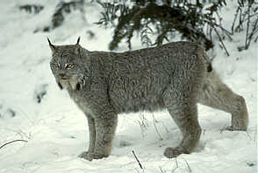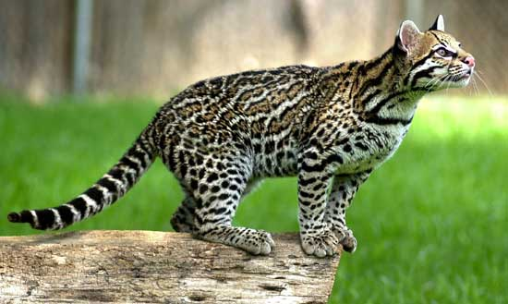
C D

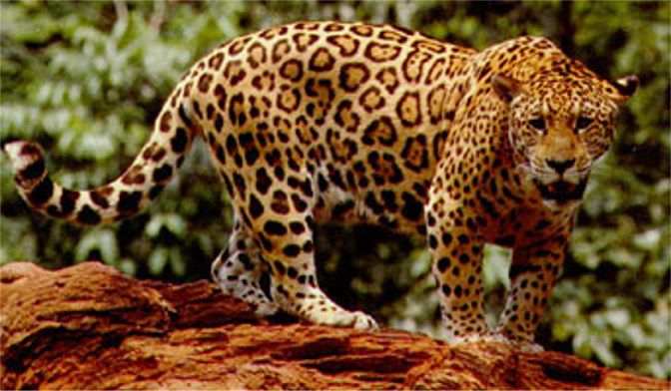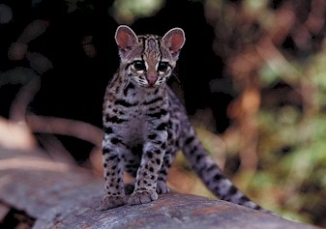
E F

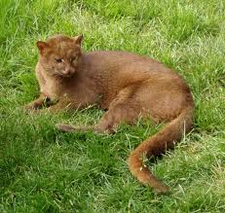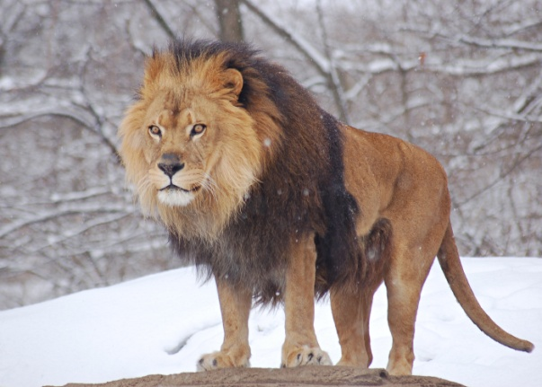
G H

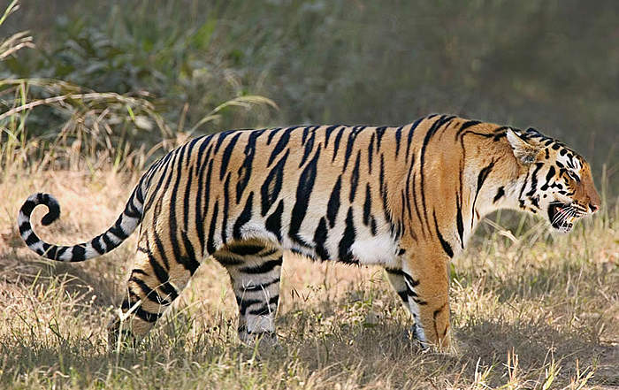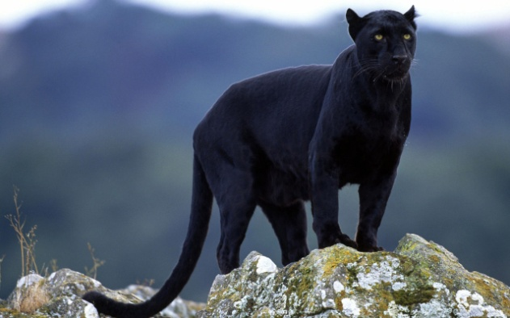
I J

Key to Wild Cats Name: ________________________
Period: ____________

1a. The cat has a short tail……………………………………………………….go to Step2
1b. The cat has a long tail………………………………………………………….go to Step 3

2a. The cat is speckled with long ear black-tipped ear tufts
and long,beard-like cheek ruff……………………………………….it is a lynx, Felis lynx
2b. The cat has indistinct spots, short ear tufts, white spots on its ears,
and a broad cheek ruff………………………………………………………it is a bobcat, Felis rufus

3a. The cat has a plainly colored body………………………………..go to Step 4
3b. The cat has a patterned body………………………………………….go to Step 7

4a. The cat has a distinct mane around
its neck (males only)…………………………………………………………..it is a lion, Panthera leo
4b. The cat has no mane around its neck…………………………..go to Step 5

5a. The cat is mostly tan to brown in color………………………go to Step 6
5b. The cat is black in color…………………………………….it is a black leopard, Panther pardus

6a. The cat is tan above with white to buff below………….it is a mtn. lion, Felis concolor
6b. The cat is brown all over the body……………………….it is a jaguarondi, Felis yagouarundi

7a. The cat has an orange colored body with noticeable
black stripes……………………………………………………………….it is a Bengal tiger, Panthera tigris
7b. The cat has a pattern on its body other than stripes……………go to Step 8

8a. The cat is clearly larger than a house cat…………………..go to Step 9
8b. The cat is about the same size as a house cat…………..it is a margay, Felis wiedii

9a. The cat has black-bordered brown spots, tending to
form lines on the body………………………………………………………it is an ocelot, Felis pardalis
9b. The cat is large, spotted with black rosettes or rings in
horizontal rows…………………………………………………………………..it is a jaguar, Panathera onca

Answer Key

- Mountain lion, Felis concolor

- Bobcat, Felis rufus

- Lynx, Felis lynx

- Ocelot, Felis pardalis

- Jaguar, Panathera onca

- Margay, Felis wiedii

- Jaguarondi, Felis yagouarundi

- Lion, Panthera leo

- Bengal tiger, Panthera tigris

- Black leopard, Panther pardus

A B

C D

E F

G H

I J

Key to Wild Cats Name: ________________________
Period: ____________

1a. The cat has a short tail……………………………………………………….go to Step2
1b. The cat has a long tail………………………………………………………….go to Step 3

2a. The cat is speckled with long ear black-tipped ear tufts
and long,beard-like cheek ruff……………………………………….it is a lynx, Felis lynx
2b. The cat has indistinct spots, short ear tufts, white spots on its ears,
and a broad cheek ruff………………………………………………………it is a bobcat, Felis rufus

3a. The cat has a plainly colored body………………………………..go to Step 4
3b. The cat has a patterned body………………………………………….go to Step 7

4a. The cat has a distinct mane around
its neck (males only)…………………………………………………………..it is a lion, Panthera leo
4b. The cat has no mane around its neck…………………………..go to Step 5

5a. The cat is mostly tan to brown in color………………………go to Step 6
5b. The cat is black in color…………………………………….it is a black leopard, Panther pardus

6a. The cat is tan above with white to buff below………….it is a mtn. lion, Felis concolor
6b. The cat is brown all over the body……………………….it is a jaguarondi, Felis yagouarundi

7a. The cat has an orange colored body with noticeable
black stripes……………………………………………………………….it is a Bengal tiger, Panthera tigris
7b. The cat has a pattern on its body other than stripes……………go to Step 8

8a. The cat is clearly larger than a house cat…………………..go to Step 9
8b. The cat is about the same size as a house cat…………..it is a margay, Felis wiedii

9a. The cat has black-bordered brown spots, tending to
form lines on the body………………………………………………………it is an ocelot, Felis pardalis
9b. The cat is large, spotted with black rosettes or rings in
horizontal rows…………………………………………………………………..it is a jaguar, Panathera onca

Answer Key

A. Mountain lion, Felis concolor

B. Bobcat, Felis rufus

C. Lynx, Felis lynx

D. Ocelot, Felis pardalis

E. Jaguar, Panathera onca

F. Margay, Felis wiedii

G. Jaguarondi, Felis yagouarundi

H. Lion, Panthera leo

I. Bengal tiger, Panthera tigris

J. Black leopard, Panther pardus

